EXPENSE SPLIT CALCULATOR
@CREATIVITY THINK (9483175986/7019689991)

ABSTRACT:
Expense Split Calculator is a web-based dynamic application designed to simplify the process of calculating shared expenses among groups of friends, students, or roommates. Users can input expenses, add payers, and instantly view each participant's share of the total cost. Administrators have the ability to monitor user logs and export data for reference via the admin panel. Developed using Django for backend processing and React with Recharts for frontend interactions, the system provides a quick, accurate, and user-friendly method to manage group expenses..

INTRODUCTION OF THE PROJECT:
Splitting expenses among groups can be tedious and prone to errors when calculated manually. Whether for roommates, student groups, or friends traveling together, tracking each person's contribution accurately is essential. Expense Split Calculator addresses these challenges by offering a centralized and dynamic platform that automatically computes each individual's share based on entered expenses. The system streamlines financial management for small groups while providing administrative oversight for logging and exporting activities..

PROJECT OBJECTIVES:

• Provide an intuitive interface to input group expenses
• Automatically calculate and display each participant’s share
• Support dynamic updates as expenses or payers are modified
• Maintain a simple user flow for ease of access
• Allow administrators to view user logs and export data
• Ensure reliable and accurate calculations
• Deliver a lightweight solution suitable for small-scale use
• Provide a scalable foundation for future enhancements

PROBLEM OF THE STATEMENT:
Groups often struggle to fairly distribute expenses due to manual calculations, inconsistent record-keeping, or miscommunication. Errors can result in disputes or inconvenience. Expense Split Calculator eliminates these issues by automating calculations, keeping records of shared expenses, and offering administrative oversight. This reduces confusion, ensures fairness, and provides a reliable, dynamic platform for small groups managing shared costs..

MOTIVATION OF THE PROJECT:
• To simplify group expense management
• To avoid errors from manual calculations
• To ensure fair distribution of costs
• To provide instant results for shared expenses
• To allow administrators to monitor usage and export data
• To create a lightweight, fast, and user-friendly tool
• To support small groups in everyday financial management

BLOCK DAIGRAM OF PROJECT:

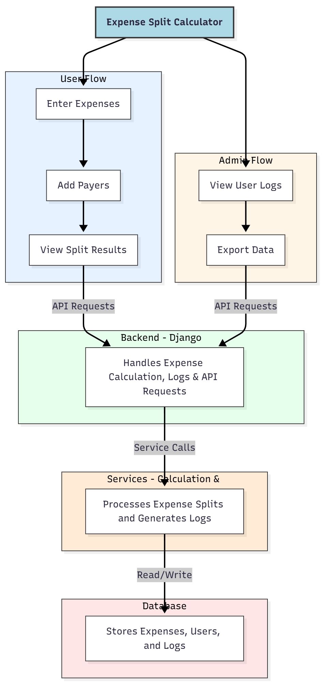

WORKING OF THE PROJECT:
Users start by entering the total group expenses and adding the names of payers. The backend automatically calculates each participant’s share based on their contribution. The results are displayed instantly on the user interface with dynamic updates for any modifications. Administrators can access logs of all user activities and export them for record-keeping. The backend ensures accuracy in calculations while the frontend provides a simple and interactive interface for users..

SOFTWARE REQUIREMENT:
- Backend:
  - Python 3.x
  - Django
  - Django REST Framework
  - SQLite/PostgreSQL
- Frontend:
  - Node.js and npm
  - React.js
  - Axios
- Development Tools:
  - Visual Studio Code
  - Postman (for testing APIs)
  - Git/GitHub (for version control)
- Server/Deployment (Optional):
  - Gunicorn, Nginx, or Heroku/AWS for hosting

ADVANTAGES OF THE PROJECT:

• Fast and accurate expense calculation
• Dynamic updates with minimal user input
• Reduces disputes and confusion over shared expenses
• Simple and intuitive user interface
• Admin monitoring and export functionality
• Lightweight and suitable for small groups
• Scalable for future improvements
• No complex setup required

APPLICATIONS OF THE PROJECT:
• Roommates sharing household bills
• Friends traveling or organizing events
• Student groups managing project or club expenses
• Small teams splitting office or departmental costs
• Any group needing simple and fair expense distribution

REFERENCES:

- Django REST Framework Documentation — Django Software Foundation. Django Documentation. Available: https://docs.djangoproject.com/
- Django REST Framework. DRF Documentation. Available: https://www.django-rest-framework.org/
- React. React Official Documentation. Available: https://reactjs.org/docs/getting-started.html
- Redux. Redux Documentation. Available: https://redux.js.org/introduction/getting-started
- PostgreSQL Global Development Group. PostgreSQL Documentation. Available: https://www.postgresql.org/docs/
- MySQL. MySQL Reference Manual. Available: https://dev.mysql.com/doc/
- Git. Git Documentation. Available: https://git-scm.com/doc
- Node.js. Node.js Documentation. Available: https://nodejs.org/en/docs/
- Axios. Axios Documentation. Available: https://axios-http.com/docs/intro
- Socket.io Documentation – https://socket.io/docs/

